November 3rd, 2022
4:00-5:00 PM EST
RHO Implementation Monthly Investigator Call Minutes
Invitees/Attendees:
Dr. Larry Rhein, Principal Investigator |  | Boston Children’s Hospital |  | Maria Fareri Children’s Hospital
Heather White, Project Coordinator |  | Children’s Hospital of Philadelphia |  | Massachusetts General Hospital
Lindsey Simoncini, Research Coordinator |  | Cincinnati Children’s Hospital |  | Nationwide Children’s Hospital
Katie Edeburn, Research Assistant |  | National Jewish Health, Colorado |  | Peyton Manning Children’s Hospital
Arkansas Children’s Hospital |  | Dartmouth-Hitchcock Medical Center |  | U. of California, San Diego
U. of Kentucky Children’s Hospital |  | University of Maryland |  | Vanderbilt

Startup/Progress
- All sites have been activated!
- 14 out of 14 sites are actively recruiting

Enrollment
- A total of 121 babies followed have been followed to date, 56 have weaned with an average HOT duration of 72 days ± 23
- Enrollment estimates predicted about 66 babies being enrolled per month, currently the average enrollment per month is 15 babies

New Centralized Email
- Please send all new enrollments as well as inquiries and questions to RHOProgram@umassmed.edu , Katie and Heather monitor it throughout the day
Update on PCORI Funding
- We have been awarded additional funds from PCORI to investigate the cost and time necessary to implement RHO as standard of care
- We are awaiting an amendment for the contract to include a seven-month no-cost extension
- Our OSP will initiate amendments to subcontracts in the coming months once the prime contract is executed

Updates on Concerns Raised by Families
- We’ve been made aware of concerns that an increased flow rate may contribute to ROP development from parents at several sites
  - Active discussion on current literature and that the concern for developing ROP has passed in infants over 42 weeks corrected. Higher flow rates may actually be protective at infants in worsening their ROP if already established.
- Parents reporting issues with battery life should be made aware that the RAD 97 has about an 8-hour battery life while disconnected from Wi-Fi and 2-3 when connected to Wi-Fi. Families should be advised to fully charge their oximeters before large amounts of time out of the house (doctors’ appointments, walks etc.).
- Families have questioned the frequency of calls
  - Active discussion around the timing of calls and the recommendations made by our Parent Advisory Board.
  - The RHO team will bring these concerns back to our PAB and discuss alternatives to the current call schedule. Note, we are not planning on changing the frequency of the data downloads.
Reminder of Flow Rates
- Please try to stick to the predetermined flow rates outlined by the RHO Program and within the Program Manual. Different flow rates and weaning trajectories will make the data hard to analyze and draw meaningful conclusions.
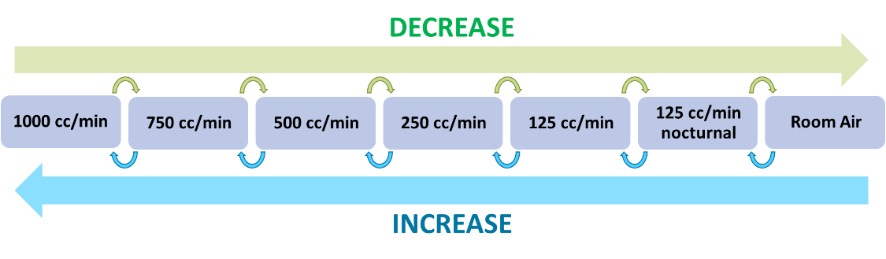
Reminder to Update Demographics
- We are currently missing screening/demographics forms for 27 babies (22%). These forms include consent to collect data and so it is imperative that these forms are filled out ASAP.
Reminders for the Family Engagement Survey
- If your site has not yet received IRB approval for the Family Engagement Survey, please contact Heather or Katie so that they may help you with any questions or concerns.
- If you site has received survey links, please send the pre-survey links at time of initial discharge and the post-survey links at time of successful discontinuation of HOT.
- Spanish versions of these surveys will be available shortly.
Reminder of Kristen Richard’s Fellowship Project
- Kristen Richard, a pulmonary fellow at BCH is conducting a secondary review of the original RHO Trial and Implementation Trial’s cohort. Additional data collection will include zip code and secondhand smoke exposure. Kristen sent an email on November 2nd to all Site PI’s explaining the project and requirements.
- Please respond to Kirsten and Heather by November 25th if interested.
Other Questions and Discussed Topics
- An early heads up that the next bi-annual data query is in December. Katie will be sending out query reports to clean and validate data in the first half of December but in the meantime please update your data and close out any subjects that are past the 6-month follow-up window.
- Concern raised for human error in the downloads and email scripts. Discussed that the team double checks and verifies all data and data emails. Site’s need to serve as the triple check and understand the rationale of the algorithm’s recommendation.
  - Please see attached PowerPoint Slide for clarification
- Thank you again for participating in our study and have a wonderful month :) Happy very early Thanksgiving!
Next Investigator Meeting will be on November 3rd at 4pm EST

