January 5th, 2023
4:00-5:00 PM EST
RHO Implementation Monthly Investigator Call Minutes
Invitees/Attendees:
Dr. Larry Rhein, Principal Investigator |  | Boston Children’s Hospital |  | Maria Fareri Children’s Hospital
Heather White, Project Coordinator |  | Children’s Hospital of Philadelphia |  | Massachusetts General Hospital
Lindsey Simoncini, Research Coordinator |  | Cincinnati Children’s Hospital |  | Nationwide Children’s Hospital
Katie Edeburn, Research Assistant |  | National Jewish Health, Colorado |  | Peyton Manning Children’s Hospital
Arkansas Children’s Hospital |  | Dartmouth-Hitchcock Medical Center |  | U. of California, San Diego
U. of Kentucky Children’s Hospital |  | University of Maryland |  | Vanderbilt
Enrollment
- A total of 154 babies followed have been followed to date, 56 have weaned with an average HOT duration of 66 days ± 22
- Enrollment estimates predicted about 66 babies being enrolled per month, currently the average enrollment per month is 15 babies

Low-Quality Signal Exclusion Algorithm Update
- Based on feedback and concerns about the impact of artifact on the download reports, particularly with older babies, we have updated our algorithm
- Working with Masimo and our own engineers we have created an update to our analysis program to automatically remove data tagged as low-quality before calculations are performed. The change was implemented the week of Thanksgiving.
- Since then, while we have observed a few babies (2/46) that have seen dramatic changes in their recommendations, but the vast majority have appeared to see only slight improvement with the most impact appearing to be on data that is borderline between increase/maintain or maintain/wean
- We will continue to monitor this data and further understand factors that may impact the amount of low signal quality
- All Rad97s are already equipped with the ability to determine signal quality and there is no need to update or replace current devices
- Additionally, at the request of the group, we have reached out to Massimo for further explanation and clarification on how the device determines signal quality and will share this information once it is available

PAB & DSMB Meetings
- We convened our bi-annual PAB meeting at the end of last month and have our DSMB meeting this month
- Major themes brought up at the PAB meeting included the setting of expectations for this program and the creation of a parent forum for parents to communicate and provide comfort/advice
- Both the PAB and DSMB meeting will be discussed in more detail at next month’s investigator’s meeting

Probes
- There have been several recent instances where the presence of a poor probe has negatively impacted the recommendation given by the algorithm
- Data from bad probes is relatively easy to spot but we, as the data coordinating site, cannot directly bring attention to this data as it would interfere with our ability to give an unbiased recommendation
- Signs for poor probe data include when the %Time Below 93% SpO2 and %Time Below 90% SpO2 are very high and very similar
- For example: with the below baby, it appears they spent 822 minutes above 96%, 826 minutes below 90%, but only 65 minutes between 90-96% and 1.1 minute between 90-93%, which is atypical

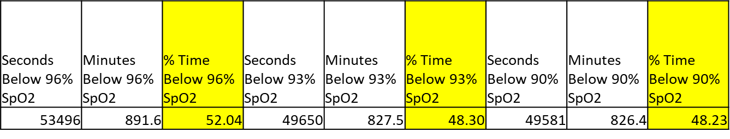

Other Questions and Discussed Topics
- We are looking to track upper-respiratory illnesses, even if not severe enough for an AE we request that you mention them in your responses to the bi-weekly recommendation emails
  - We will add language to the recommendation emails as a reminder
- If you have not yet sent an official response to the data queries sent out by Katie (Katherine.Edeburn@umassmed.edu) on December 1st, please do so as soon as possible
- AE events must be reported for all babies following the program or serving as a control for 6 months post-wean
- Heather has returned full-time to PA School. If your question requires prompt attention, please email Katie or the RHO Program central email (RHOprogram@umassmed.edu)

Next Investigator Meeting will be on February 2nd at 4pm EST

