Chalk Talks

Goal: Prepare and teach from 20-30 mins on any topic using an image. Invite an attending to sit in on the talk for feedback on your teaching.

Resources:
- Woo insider: How to Teach and Chalk Talk, Dr. Jay Kachoria
- AAP Section on Hospital Medicine Library (see Teaching scripts, plus more!)
  - Login with your AAP account and navigate to the SOHM Library
- Clinical Problem Solvers Diagnostic Schema
- One page chalk talk overview

Examples:

- Sickle Cell Disease
- Cystic Fibrosis
- Diabetes and Diabetic Ketoacidosis
- GI bleeds
- Pancreatitis
- Elevated liver enzymes
- Asthma and status asthmaticus
- Seizure management
- Developmental Milestones
- Inflammatory Bowel Disease
- EKG Basics
- Febrile newborn
- Failure to thrive
- Acute abdomen
- Nephrotic syndrome
- Nephritic syndrome
- Kawasaki Disease
- Bronchiolitis/Pneumonia
- Urinary tract infections
- Skin and soft tissue infections
- Leukemia/Lymphoma
- Brain tumors
- Congenital infections

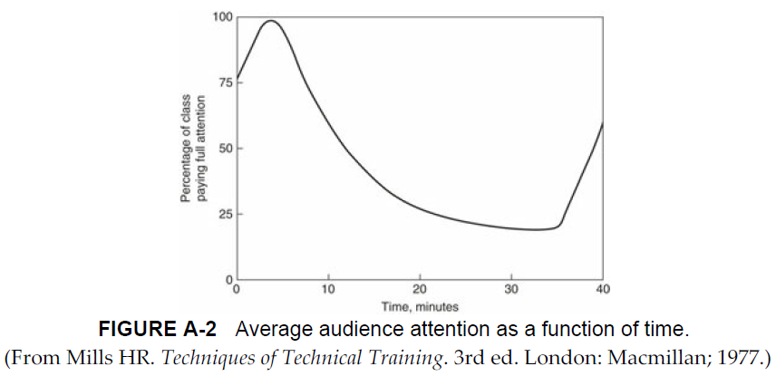

Chalk Talk: off-the-cuff teaching relevant to current medical care using paper or a white/chalk board

- Timeliness 🡪 <20-30 minutes
  - Strong leadership
  - Stay on task
- Relevance 🡪 current medical problems
  - Generalized
  - “Hard” findings
- Verbalization 🡪 structure and preparation
  - Learning objectives
  - Talking > writing
  - Teaching Scripts and Diagnostic Schemas

- Participation 🡪 ask questions
  - Allow the learners to do the bulk of the talking
  - Use the Socratic method

- Adaptability 🡪 based on the level of the learner(s)
Training level | Chalk Talk
MS3 | Key findings
MS4/PGY1 | Initial framework
PGY2-4 | Work-up/Management
Attending | Finer points

- Completeness 🡪 round out the corners
  - Start and end with learning objectives
  - Self-reflection and feedback
Document created by Dr. Jay Kachoria
Chalk Talk Example – feel free to use these as inspiration or create your own

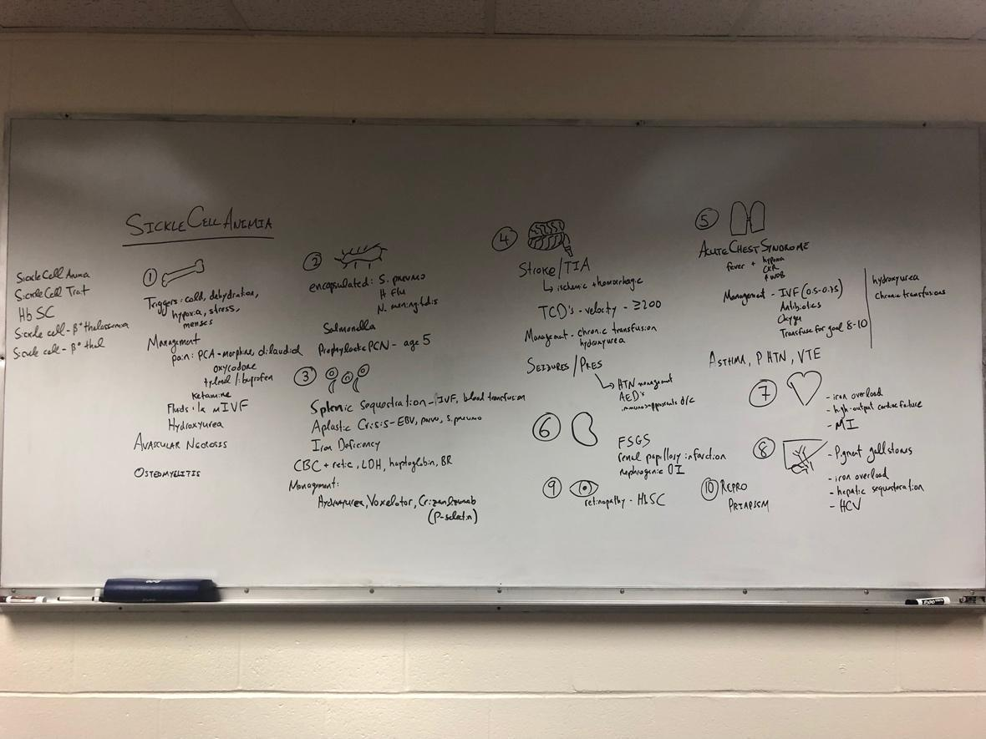

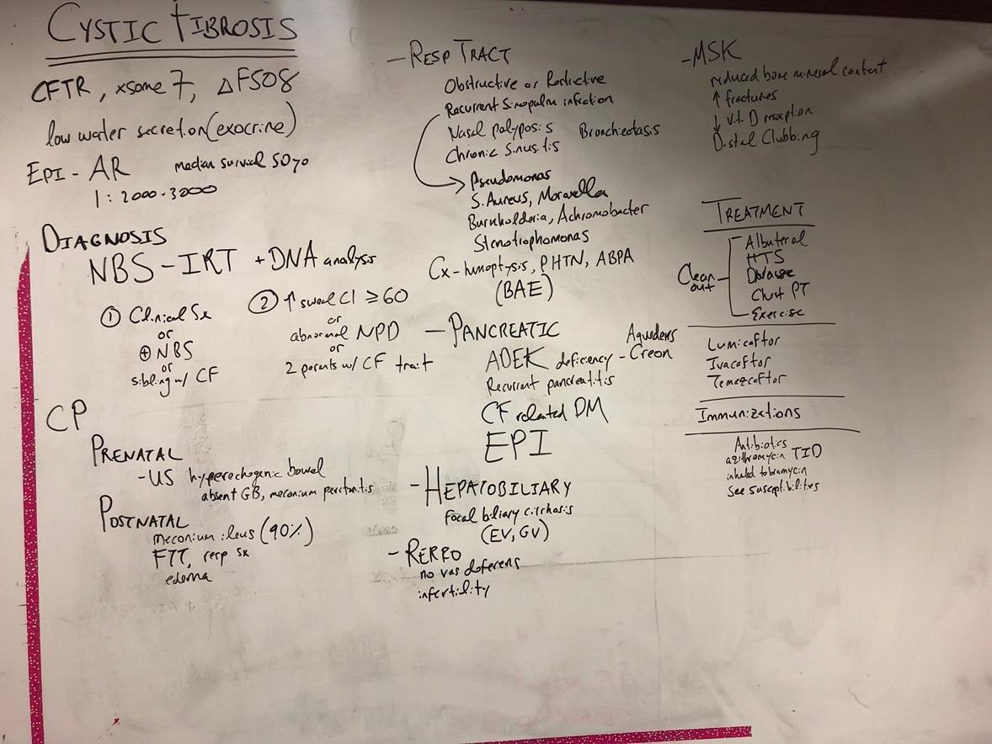
Created by Dr. Harun Thimmiah

Noon Conference Educational Activity
Goal: Lead and organize a noontime educational activity for residents and medical students, discussing a topic of interest, sharing clinical reasoning and frameworks of thinking
Be creative and utilize any type of learning format
Options:
- Review board questions
- Medical Pictionary with slides sharing learning points
- Medical Jeopardy

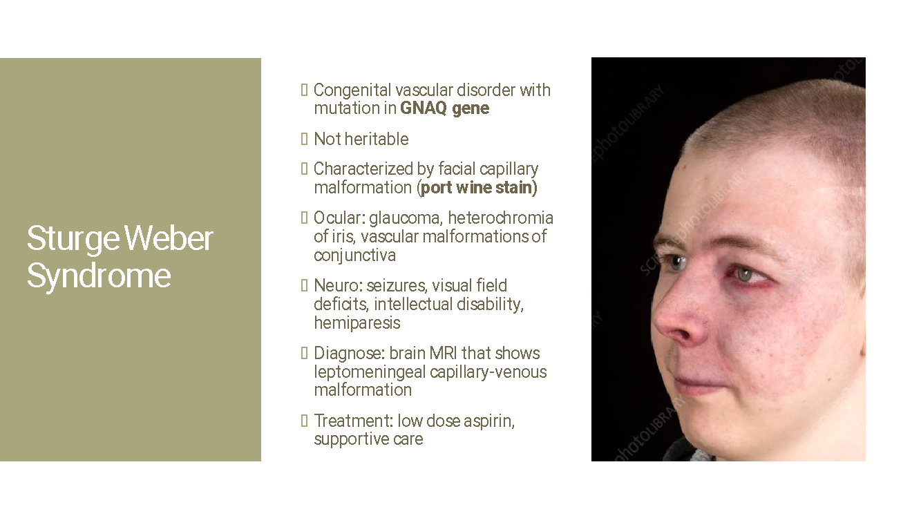
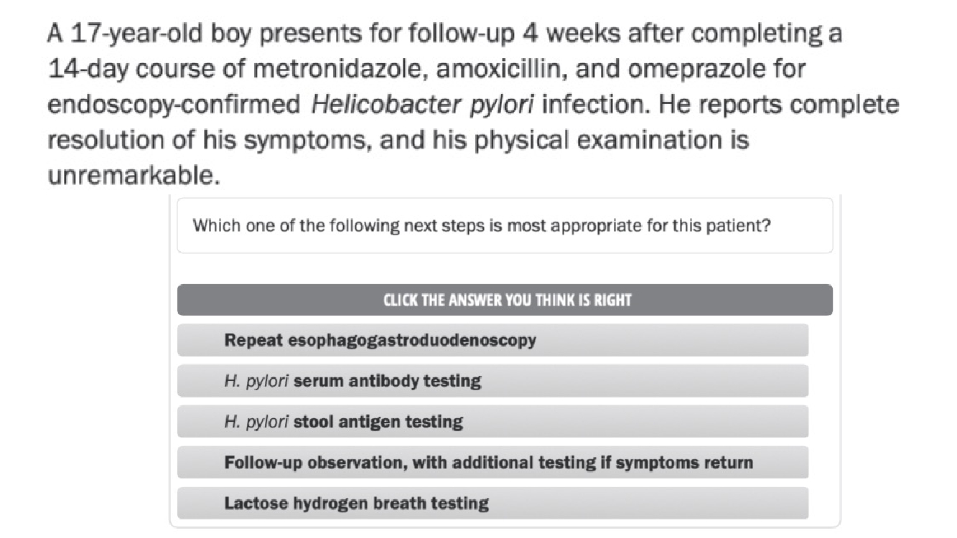

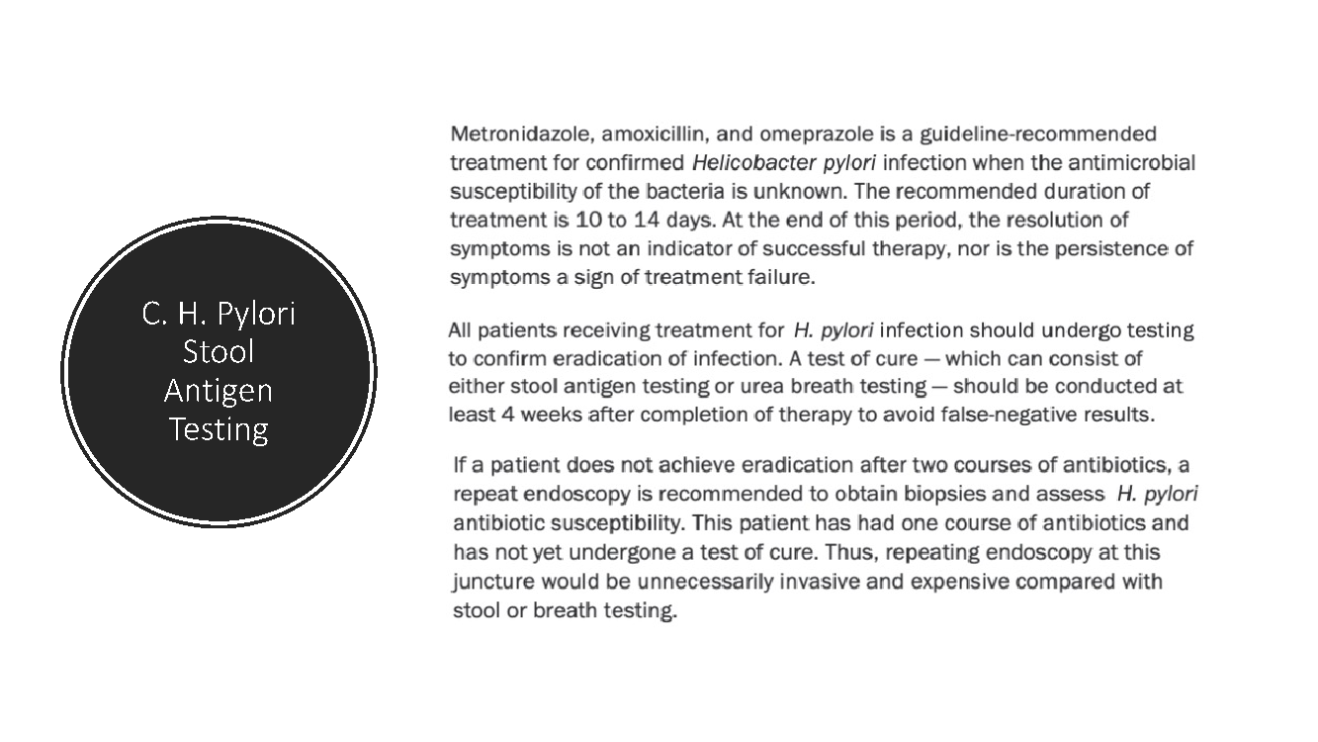

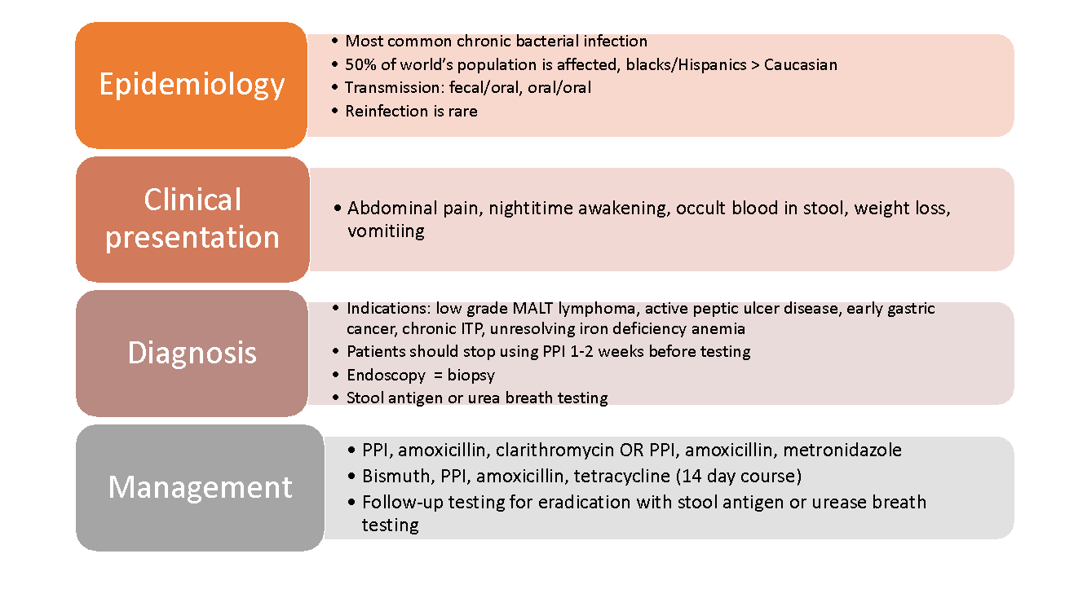
Created by Dr. Harun Thimmiah
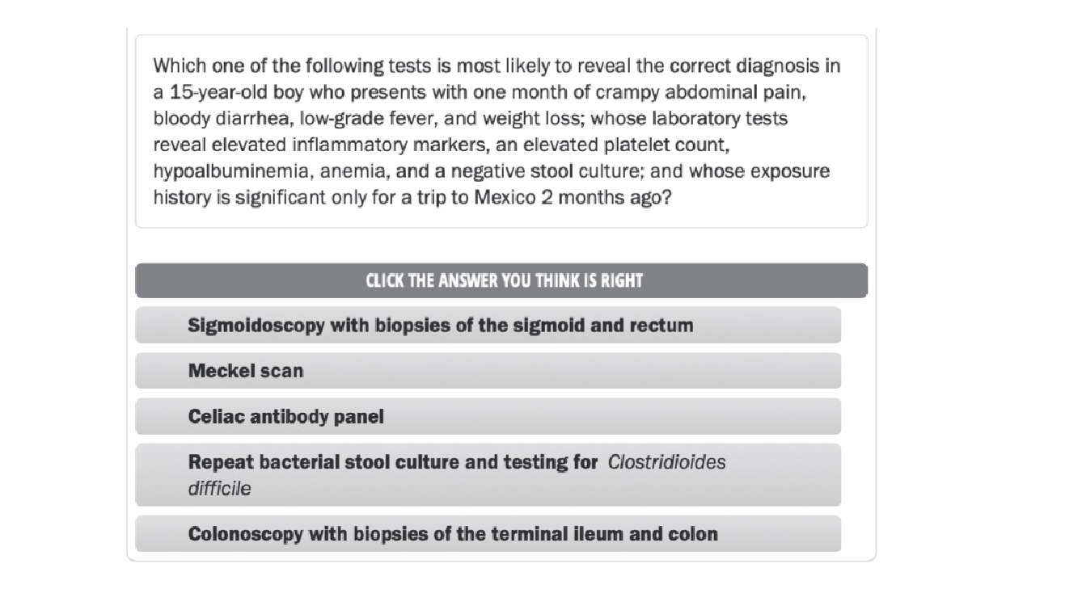

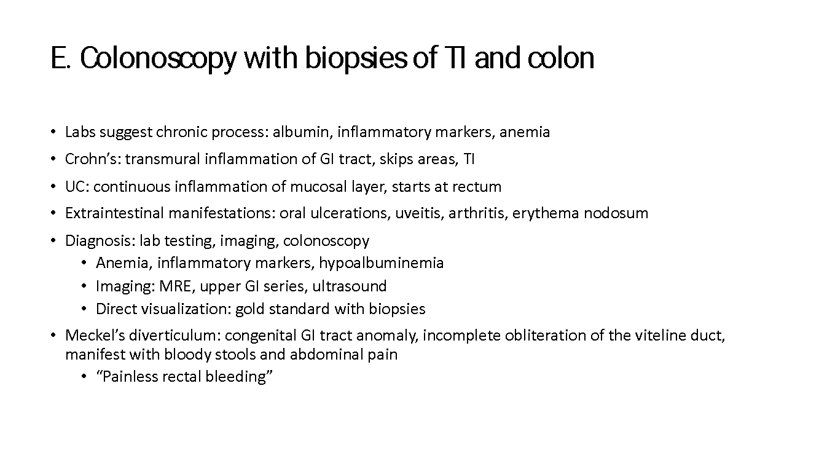

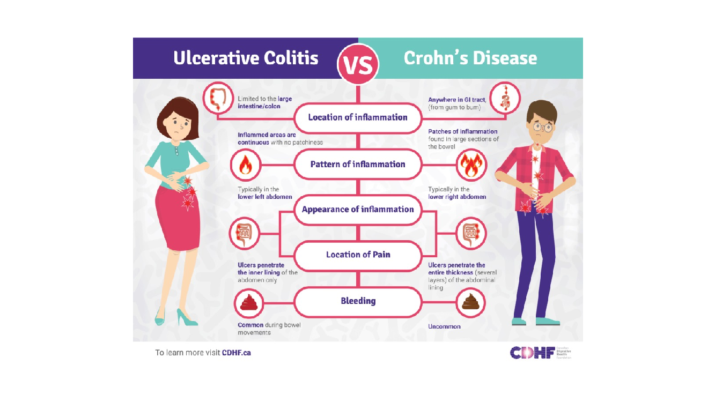
Created by Dr. Harun Thimmiah

BEDSIDE TEACHING

Goal: Organize and teach history taking and physical exam techniques at bedside with patient and family

Resources:
- Woo Insider: Bedside teaching lecture by Dr. Christopher Driscoll
- Teaching Scripts

Instructions:
- On Thursday, after attending simulation, attend PUP rounds and identify 1-2 patients who would be good bedside teaching patients
- Meet with patient and family prior to assembling
- In the afternoon, assemble medical students for bedside teaching

SIMULATIONS
Reading resources:
- OPENPediatrics
- IPSS education webinars
- Shetty R, Thyagarajan S. Simulation in pediatrics: Is it about time?. Ann Card Anaesth. 2016;19(3):505-510. doi:10.4103/0971-9784.185543
- MedEdPortal Pediatric Simulation Publications
Contact Kate Wynne or look on Woo Insider for simulation template to fill out to write your own

Teaching Script
Author: Jan Fune, MD
Topic: Bagged vs. Catheterized Urine Sample
Identify the Trigger  Based on patient situation/learner | Learner states “Can we get a bagged urine sample?” for an infant >2 months of age or a toddler under 24 months of age with fever or signs/symptoms concerning for UTI.
High Yield Teaching Point  What do they need to know that will impact their care of patients | Accurately diagnosing a UTI is critical in order to prevent further ascension of the infection and to determine the appropriate antibiotic for treatment. If we chose to use a bagged sample, we can only use it for a urinalysis but not a culture because of the likelihood of contamination.
Identify EBM  Find your sources and specific evidence | - Balighian E, Burke M. Urinary Tract Infections in Children. Pediatrics in Review 2018;39;3  - Urinary tract infection: clinical practice guideline for the diagnosis and management of the initial UTI in febrile infants and children 2 to 24 months. Pediatrics 2011;128;3
Describe Strategy  Interactive, analogies, visuals | Use the think-pair-share method and have learners debate the pros and cons of obtaining a bagged vs. catheterized sample or use the one minute preceptor model
Keep Script Brief  5-15 minutes; what are your key points | Get a commitment: “Do you want to obtain a cath or bagged urine specimen?”  Probe for evidence: “Why?”  General rules:  Catheterization is quick and urine culture results are more accurate, but it can cause the patient pain and discomfort.  A bag specimen may prevent pain and discomfort from catheterization, but if the UA findings are abnormal, you would need to collect a specimen via catheterization to confirm UTI. This may prolong the amount of time before you start empiric antibiotic treatment. This could be further prolonged considering the amount of time for the patient to void into the bag.  Additional script: What are other risk factors that could help you stratify the risk of your patient having a UTI vs. another source of fever?  In the absence of other obvious symptoms (i.e., cough, congestion), up to 7% of febrile infants and toddlers without an obvious source of fever have a UTI. How does this change if it’s an uncircumcised male?

Author:
Topic:
Identify the Trigger
Based on patient situation/learner
High Yield Teaching Point
What do they need to know that will impact their care of patients
Identify EBM
Find your sources and specific evidence
Describe Strategy
Interactive, analogies, visuals
Keep Script Brief
5-15 minutes; what are your key points

Review teaching scripts published on SOHM library- use them in your bedside teaching and follow instructions to submit your own! Send to Catherine Ezzio for review before submission.

WOO INSIDER TOPIC

Goal: create a one-page document that summarizes a topic succinctly for the Woo Insider

Instructions:
- Choose topic to summarize
- Choose faculty member who is expert in field to review material and enhance document with supplemental readings
- Create one-page document and send to Dr. Kate Wynne to be placed on Woo Insider

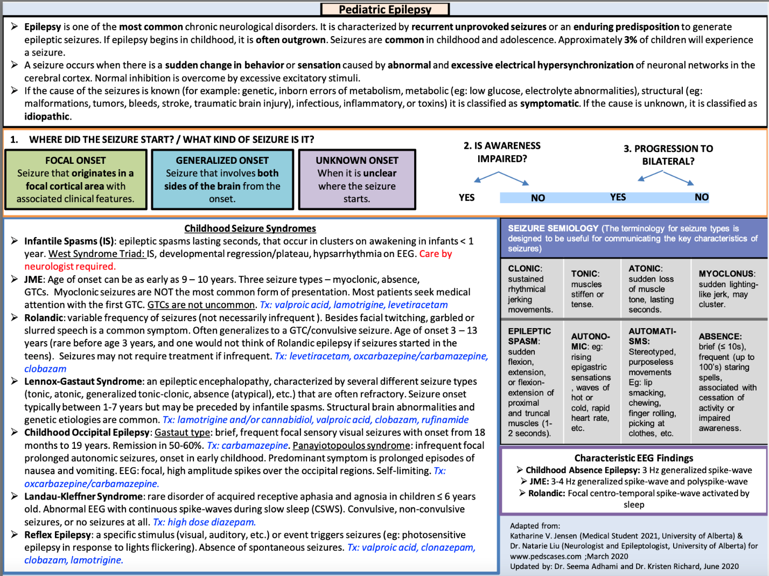
Created by Dr. Kristen Richard
Reviewed by Dr. Seema Adhami

Autism Spectrum Disorder
Authored by Dr. Alison Casserly
**tip: Find an extended version of this teaching on the DBP Rotation page
Objectives:
- Define DSM-V criteria for ASD and identify early warning signs and symptoms.
- Review the proper use and scoring of Autism screening tools (e.g., MCHAT-FU, RITA-T)
- Review the differential diagnosis of ASD, so that other autism-associated disorders or medical problems are not overlooked.
- Review therapies for ASD and become familiar with resources for making referrals to appropriate evaluations/services (including Early Intervention)
- Understand the process of developing individualized education plans in schools and parents’ rights to ensure patients receive proper services.
Articles:
- DSM-V Criteria for ASD
- Identification, Evaluation, and Management of Children with Autism Spectrum Disorder (Pediatrics, 2020)
- Clinician’s Guide to Autism (Peds in Review, 2014)
- Primary Care Autism Screening and Later Autism Diagnosis (Pediatrics, 2020): Study finding although the majority of children are screened for ASD, there are disparities in among those that complete screening. Screening is less likely to occur in Hispanic children. Children who screen positive are more likely to be diagnosed with ASD at a younger age compared to those who screen negative.

Additional Resources:
- AAP Surveillance and Screening Algorithm: Autism Spectrum Disorder
- M-CHAT-R/F: Freely available online level 1 screening tool recommended for ASD-specific screening for at all well-child checks at 18 and 24-30 months. Parents/caregivers fill out this questionnaire which is scored by a provider. Level 1 testing.
- CDC Act Early Autism Case Training (ACT): Free web-based continuing education course to help clinicians better identify ASD, assist families through the diagnostic process, and care for patients with ASD through 3 training modules. The modules incorporate useful videos illustrating typical and autism behaviors as well as examples of how to have difficult conversations with parents and caregivers.
- CHOP Open Access Medical Education: Autism Spectrum Disorder: (2018) Video recording of a lecture presentation by Susan E. Levy MD, MPH covering diagnostic criteria, core clinical features, epidemiology, screening and diagnostic strategies, current treatments, and guidance for parents.
- Peds RAP - New Therapies in Autism: Part One: Podcast recording with autism expert Shafali Jeste, MD discussing legitimate and unproven autism therapies. There is special focus on treating insomnia/sleep disturbance in ASD with melatonin. Other CAM therapies that are considered unsafe are discussed.

Self Assessment:
1. A 24-month-old boy is brought to your office by his mother who tells you she is concerned about his speech and behavior. She reports that her son uses a total of 10 single words to communicate. He grabs her hand to place it on things that he wants. He does not point or make eye contact. The boy has tantrums when there is any change in his routines or when he hears loud noises. He is fascinated with lights, and does not respond to the presence of other children. His hearing evaluation and physical examination findings are normal. The boy’s mother tells you that he has a cousin with “delays.”
Of the following, the BEST next management step for this boy is to
- administer the Childhood Autism Spectrum Test
- assist the family in accessing an Individualized Family Service Plan
- order a functional magnetic resonance imaging study
- order electroencephalography
- recommend twice-monthly applied behavioral analysis therapy
2. A 4-year-old girl presents for a health care maintenance visit. Which of the following is the most appropriate screening tool for this girl for autism spectrum disorder (ASD)?
- Autism Diagnostic Observation Schedule
- Childhood Autism Screening Test
- Communication and Symbolic Behavior Scales and Developmental Profile
- The Infant Toddler Checklist
- Modified Checklist for Autism in Toddlers
3. A 2-year-old boy presents with severe language delay. Which of the following tests should be administered first?
- Audiology testing
- Comparative genomic hybridization array
- Fragile X syndrome testing
- Lead level
- Metabolic testing
4. Parents of a 4-year-old girl diagnosed as having ASD want to know the best, most accepted complementary and alternative therapies for their child’s disorder. Which of the following therapies is best accepted in this category?
- Chelation for heavy metal poisoning
- Hyperbaric oxygen therapy
- Massage therapy
- Melatonin therapy
- Vitamin B12 shot therapy
5. Developmental surveillance is performed at every well child visit, with questions like, "Do you have any concerns about your child's growth and development?" At what ages does the AAP recommend that developmental screening be performed? Select all that apply.
- 2 months
- 4 months
- 6 months
- 9 months
- 12 months
- 15 months
- 18 months
- 24 months
- 30 months
Find the answers here.

