TO DO!
- Woo Insider review
- Protected Time QR code for blue/yellow teams
- Apps: Uptodate, Haiku, OpenEvidence, ChatGPT
- The Hub
- Epic set-up as noted below
UMass Pediatrics – Intern Orientation Epic Groundwork
K Wynne, Updated June 2025
Thanks to the fabulous Drs. Jordi Morgan, Samm Rosenblum, Anjali Oberoi, Sara Hyde, Ben Cook, and Colby McGinn for help preparing/updating this over the past few years!!

WELCOME!!!! We are pumped for you to begin residency with us! To help prepare you for various rotations, we recommend getting your Epic layout prepped. Here are our recommendations for starting out. Of note, there’ll be more to customize on the fly, but we hope this guide gives you a solid foundation.
- Create your patient lists – Name lists, link clinical areas, and prepare the columns. Under “Edit List” select “Create My List.” You’ll need to do this a few times to create all the lists needed for the various clinical areas
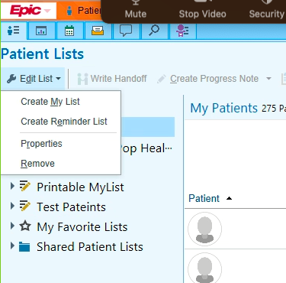
As you open and create each list, you will enter in a list Name and you will enter in a specific code (under the “Copy” feature of the List Properties – see star) so that the columns of your patient lists within each area are vetted/useful.
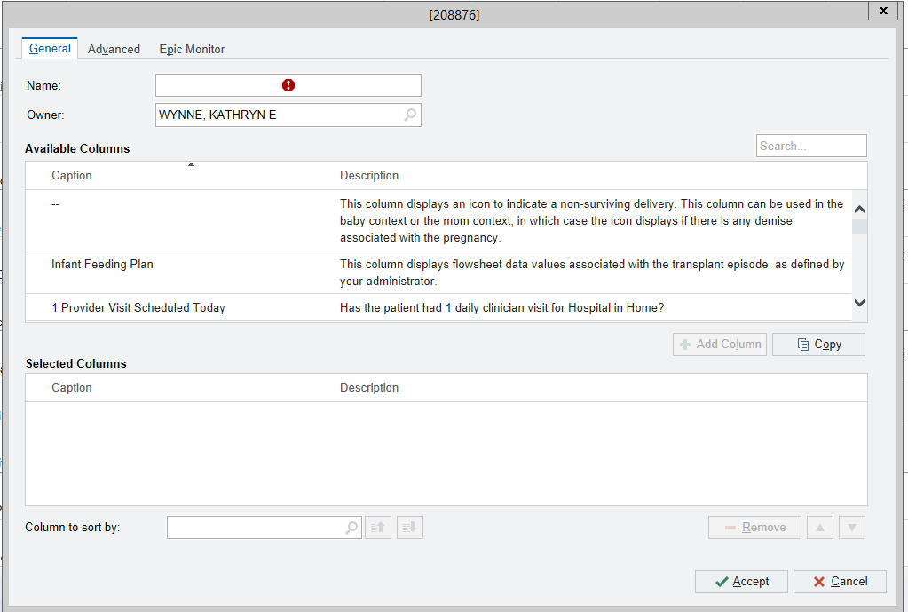
- As an example, to make your “PICU” list… select “Edit List” “Create My List” Name it “PICU” Select the “Copy” button and type “148608” Hit “Accept” and then “Accept” again.
- Do this until you have all of the following lists with titles and “copy” codes:
- Newborn Nursery – 108627
- NICU - 208873
- Pedi ED – 52356
- PICU – 148608
- Wards Teams All – 52357
- Wards Yellow – 52357
- Wards Blue – 52357
- Wards Red – 52357
- Wards All Floor Patients – 52357
- Once you have all of the above lists created, you’ll need to drag and drop the appropriate lists from the “Available Lists” section just below “My Lists.” Here’s what you’ll need:
  - “Newborn Nursery” Memorial Campus, Units add all the following: MEM 4 Newborn Boarder, MEM 4 Nursery, MEM 4 South Nursery (**Of note – when you rotate in the nursery, Dr. Mark Vining will provide a Shared List for you as well)
  - “NICU” Memorial Campus, Units MEM 5 NICU
  - “Pedi ED” University Campus, Units add both UNV Emergency Dept Peds and UNV Peds ED
  - “PICU” University Campus, Units UNV 5 Pedi ICU
  - “Wards Teams All” University Campus, Ward Teams UNV Pediatrics – All
  - “Wards Yellow” University Campus, Ward Teams UNV Pediatrics Yellow
  - “Wards Blue” University Campus, Ward Teams UNV Pediatrics Blue
  - “Wards Red” University Campus, Ward Teams UNV Pediatrics Red
  - “Wards All Floor Patients” University Campus, Units UNV 5 Pediatrics
- Nice work! Other ideas to think about: Some residents create lists for other purposes – e.g. patients to follow-up later, cases for morning report, or primary care patients.
- You can also “Default” a favorite list so it is the list that appears first simply by right-clicking the list heading that you would like and selecting “Default List.” Of note – this will also mean the list is what appears on Haiku when you open it!
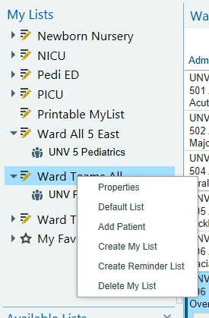
- Set up your main chart tabs – This you will have to do manually. We recommend the following layout. You’ll need to open a patient’s chart and do some drag and drop. To select a color, first right click the tab and select “Mark tab as important.” Then you’ll be allowed to choose a color.
- Top chart review screenshot:

- Set up your tabs within the “Summary” tab – Another manual bit of work using the wrench. I recommended starting with the tabs below!
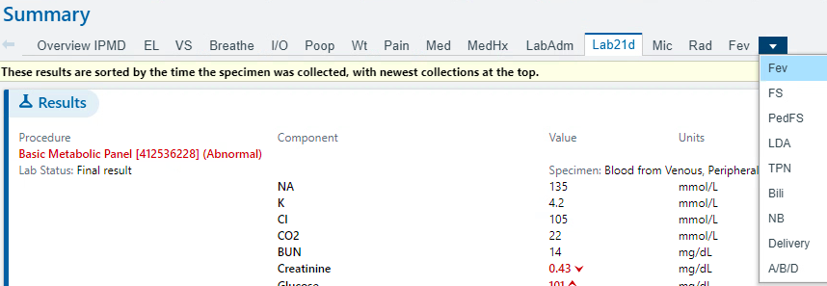

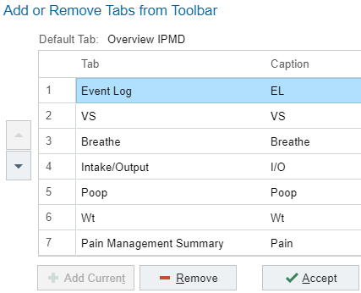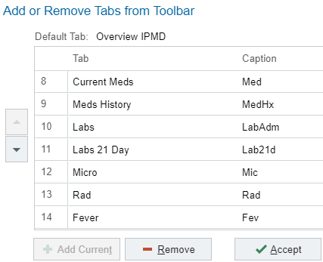
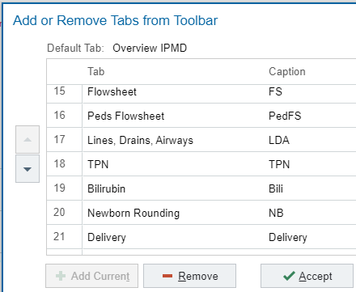

- Set up your tabs within the “Chart Review” tab – yep, more manual moving of things!
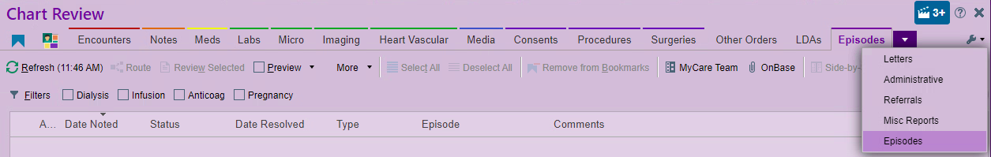

- Unique for the nursery, you will want to add the “Peds Overview” to your Sidebar Summary. More to come when you hit that specific rotation.
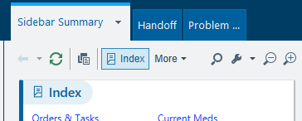
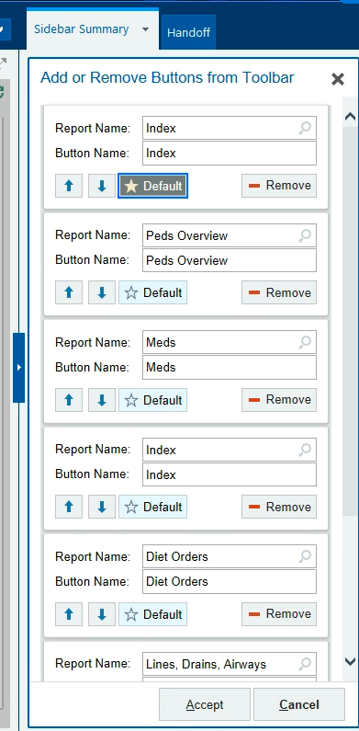

- Unique for the PICU, add the “Global Issues” tab from the main pane over to the right Sidebar. More to come when you hit that rotation! Note: You will need to make this change while you are in a PICU patient’s chart.
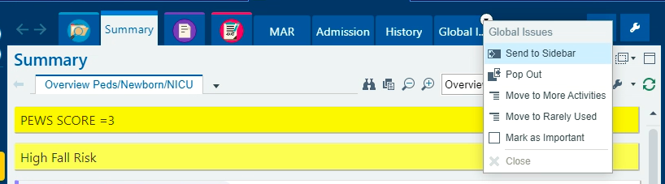

- Copy preference list favorites – go to “My Tools” or “Personalize” along the top bar “Preference List Composer” “Copy User Lists” and copy “Kathryn Wynne”
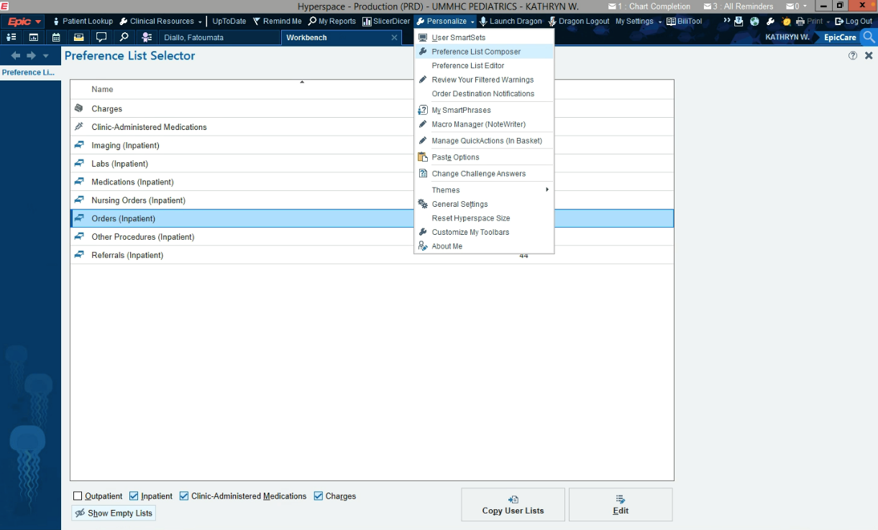

- You can also “Follow User” preferences to learn more things over time!

- You will want to personalize the Toolbar items along the top. Make sure you have Clinical Resources, UpToDate, My Tools.
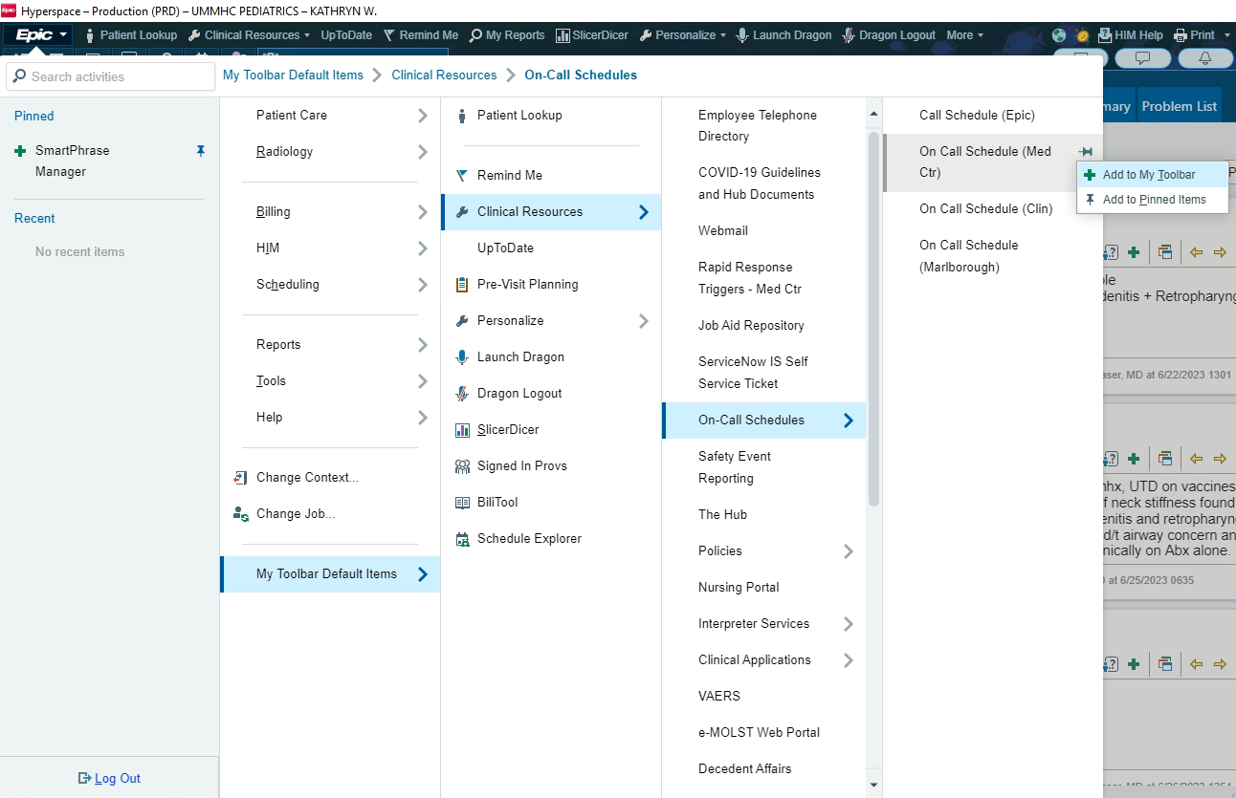

- Save some dot phrases
An ongoing project is developing a standard list of dot phrases (they all start with “.pedres…”). Keep checking these for new options! In the meantime, you can go to the “SmartPhrase Manager”, select the level of “department” and then “SmartPhrase Lookup” to search for them. You can search by user as well if you see that someone has one you like! Your seniors should be helping you as you go along. There may be rotation-specific phrases that you will learn when you are there (e.g. NICU).
***If you would like to make/suggest a new .pedres phrase – let Kate know!!!
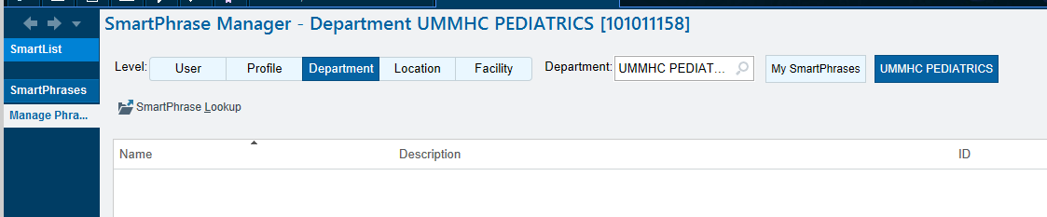

- Just a plug for charting… In order, in order for PMH, FH, SH, etc to pre-populate into your notes, you need to enter it into the designated sections of Epic, and NOT simply type it into the body of your note. If you put it in the correct Epic locations, it will automatically pull in to notes – e.g. H&Ps, Consults, Discharge Summaries. You can find the correct locations within the “Admission Navigator” or if you use the “History” tab.
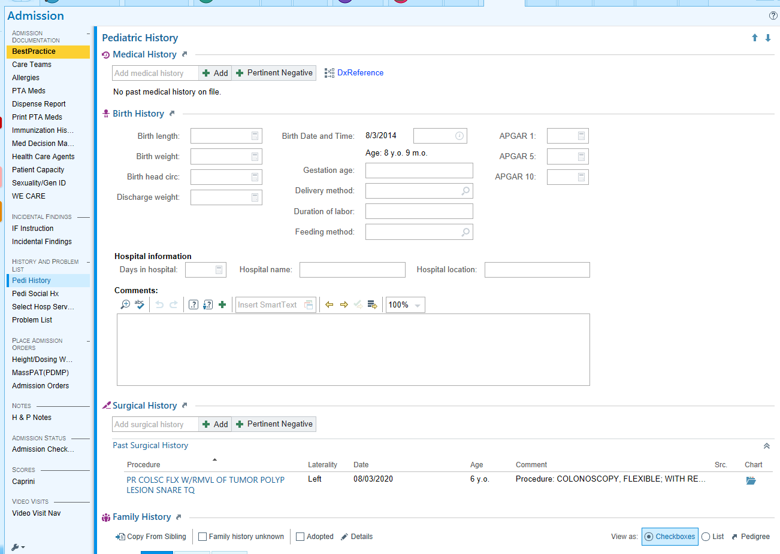

- And lastly, a plug for Billing… (especially this year!)
  - How notes are written has dramatic implications for how successful billing is. We take care of complex kids and we should make sure our hospital system is paid appropriately. UMass cares for a large population of patients on public insurance programs which means we run on much thinner margins than our neighbors with higher ratios of private pay patients (e.g. MGB, BCH).
  - You do not need to bill as a resident, but you can help support attending billing by:
    - While on the wards, please use the .pedres phrases as they come along – we are building them to make your work easier/better and to promote billing
    - Update the Hospital Problem List often
    - Incorporate all applicable “problems” into your A&P. Not only the symptom or diagnosis (e.g. epigastric abdominal pain, multifocal pneumonia, influenza, acute cough, dizziness) but also exam or lab findings that are pertinent (tachycardia, respiratory retractions, elevated CRP, hypokalemia, metabolic acidosis).
  - If you are interested in billing, ask your attending for their 2 min spiel! Billing is completely different depending on what you do/clinical care setting.

PLEASE!! Give me feedback on how this all works out. I hope this helps you hit the ground running!! WELCOME!!

