HOLIDAY MENU IBD-AIDTM PHASE I

Starter: Carrot and Ginger Soup
https://www.umassmed.edu/nutrition/ibd-aid/soups/carrot-and-ginger-soup/

Main Course: Holiday Turkey Bake
https://www.umassmed.edu/es/nutrition/ibd-aid/entrees/turkey-bake-for-phase-1/

Vegan Option: Carrot Spinach Oat Groats
Carrot Spinach Oat Groats (umassmed.edu)

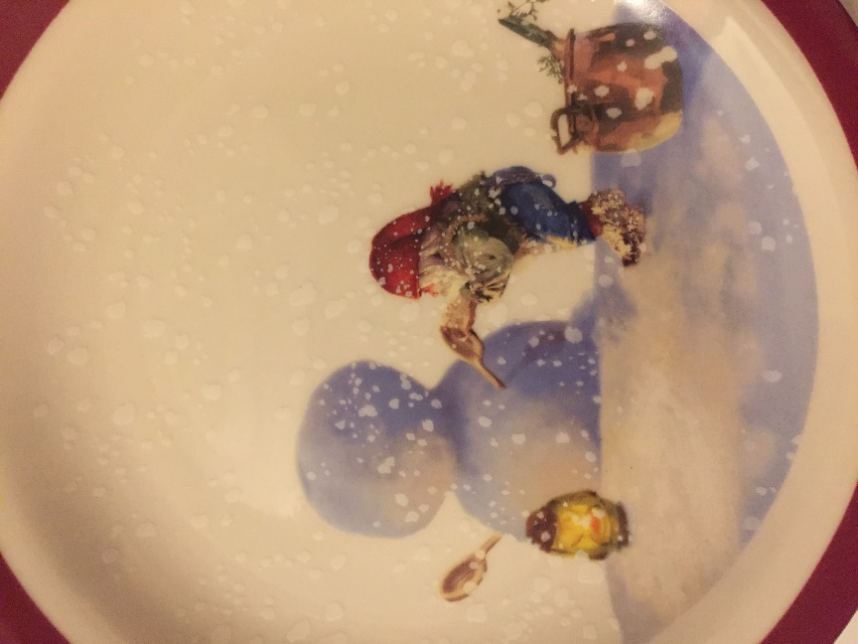
Sides: Cashew Cream Spinach Puree
Cashew Cream Spinach Puree (umassmed.edu)

Butternut Squash Puree
Butternut Squash Hemp Seed Puree (umassmed.edu)

Dessert: Vanilla Custard
https://www.umassmed.edu/nutrition/ibd-aid/desserts/vanilla-custard/

For more IBD-AIDTM Phase I recipes visit https://www.umassmed.edu/nutrition/ibd-aid/
HOLIDAY MENU IBD-AIDTM PHASE 2
HOLIDAY MENU IBD-AIDTM PHASE 2
Starter: Butternut Squash Bisque
https://www.umassmed.edu/nutrition/ibd-aid/soups/butternut-squash-bisque/
Main Course: Braised Chard with Chicken and Steel Cut Oats
https://www.umassmed.edu/nutrition/ibd-aid/entrees/braised-chard-with-chicken-and-steel-cut-oats/
Vegan Option: Carrot Spinach Oat Groats
Carrot Spinach Oat Groats (umassmed.edu)
Sides: Sauteed Green Beans with Mushrooms
https://www.umassmed.edu/nutrition/ibd-aid/vegetables/sauteed-green-beans-with-mushrooms/
Stuffing for Turkey
https://www.umassmed.edu/nutrition/ibd-aid/salads_and_side_dishes/stuffing-for-turkey/

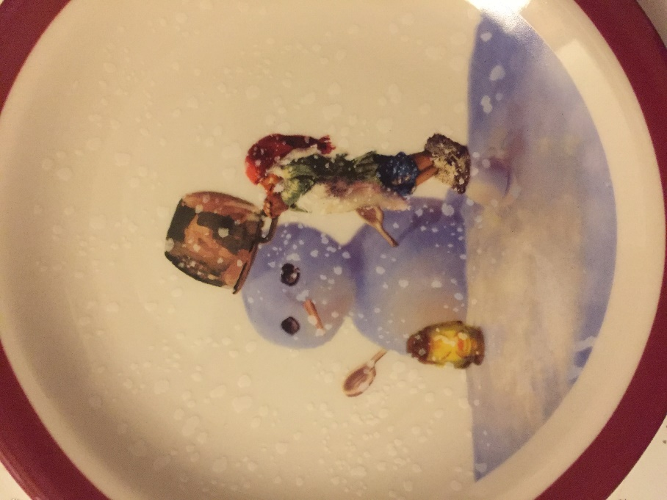
Dessert:
Pumpkin Pie Chia Seed Pudding Parfait
Pumpkin Pie Chia Seed Parfait (umassmed.edu)
For more IBD-AIDTM Phase 2 Recipes visit https://www.umassmed.edu/nutrition/ibd-aid/

-id/
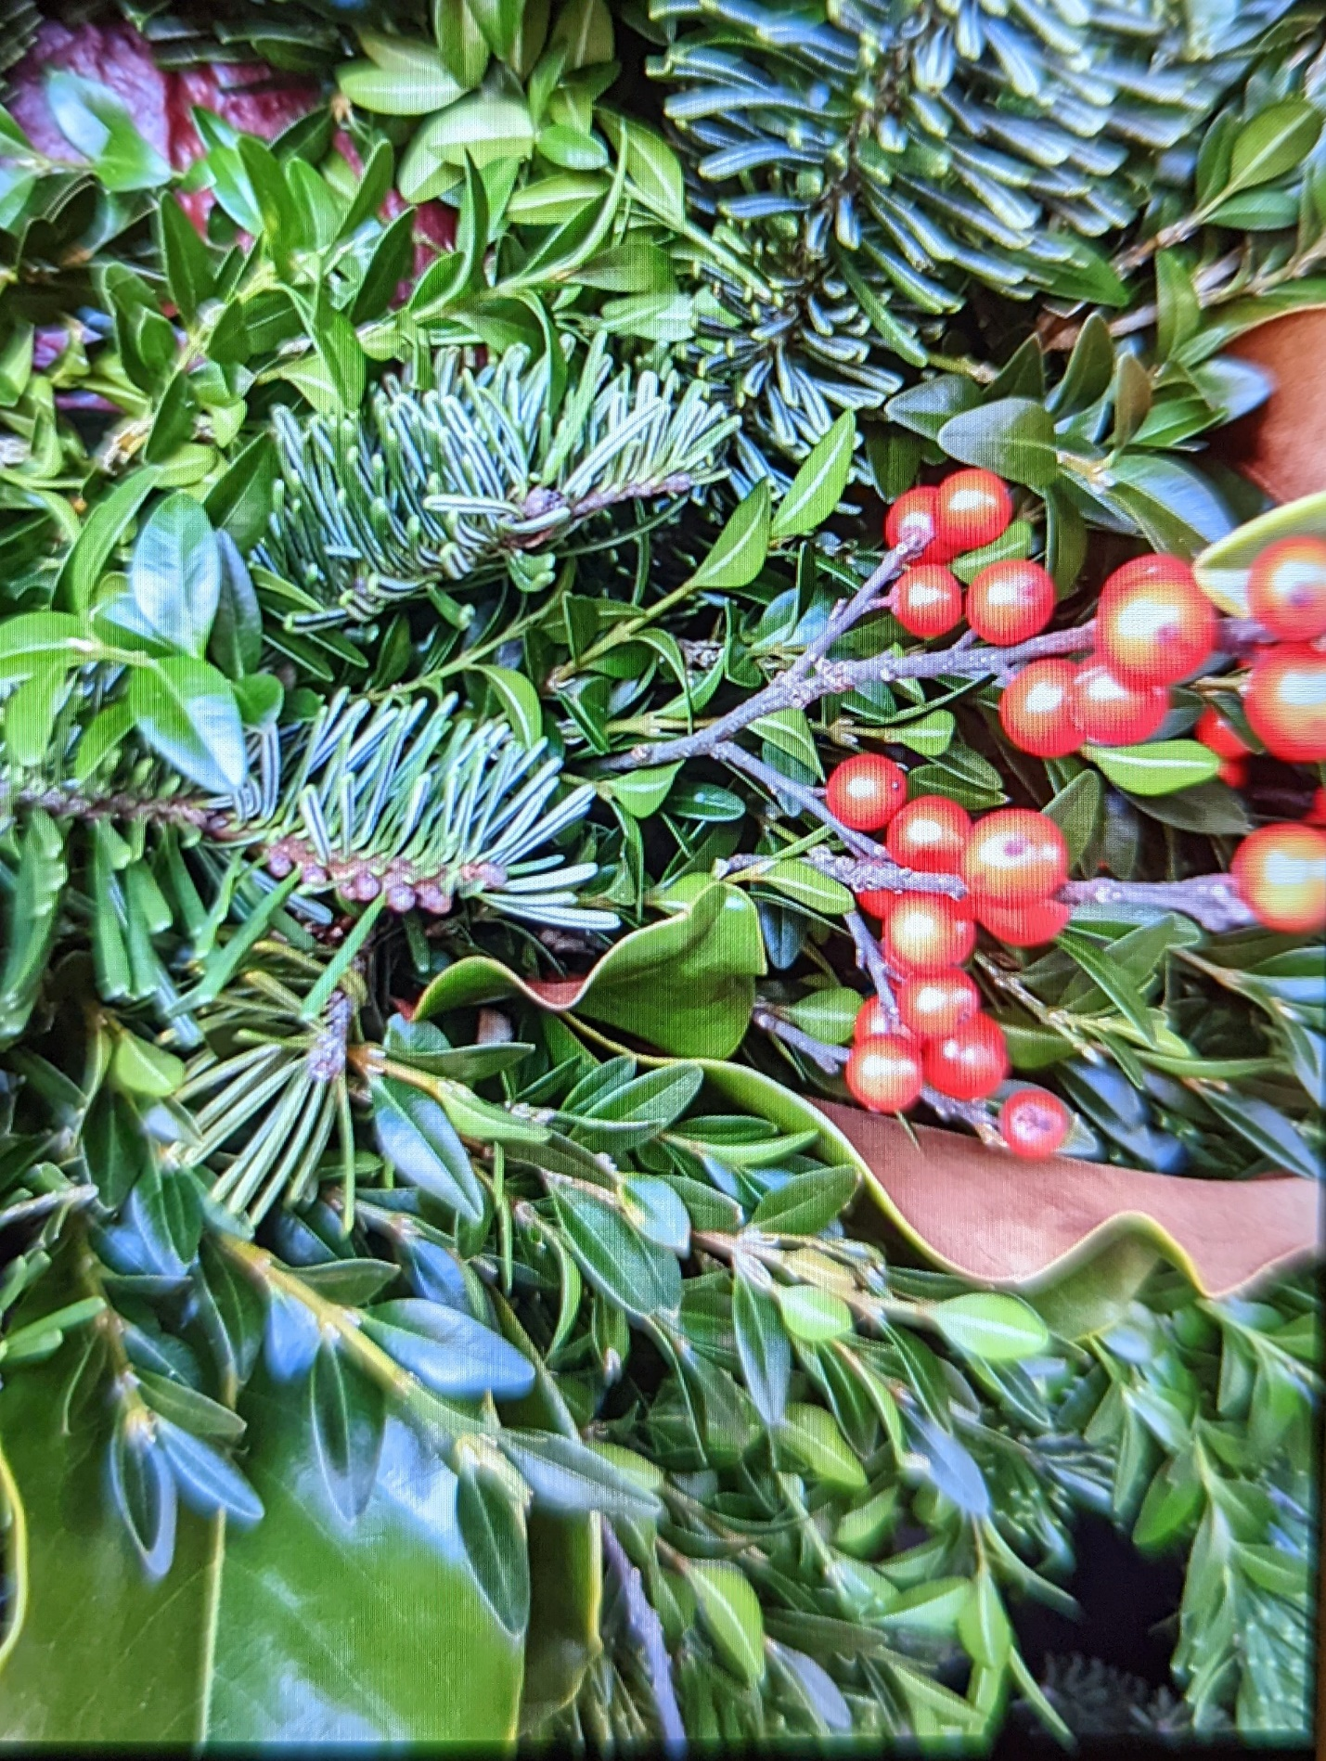
HOLIDAY MENU IBD-AIDTM PHASE 3
Starter: Mushroom Kale Miso Oat Soup
https://www.umassmed.edu/nutrition/ibd-aid/soups/mushroom-kale-miso-oat-groat-soup/
Main Course: Cran-Apple Turkey Medallions
https://www.umassmed.edu/nutrition/ibd-aid/entrees/cran-apple-turkey-medallions/
Vegan Option: Oat Groats & Roasted Root Vegetables over Arugula
https://www.umassmed.edu/nutrition/ibd-aid/salads_and_side_dishes/oat-grouts--roasted-veggie-arugula-salad-with-lemony-chia-seed-dressing/
Sides: Garlicky Green Beans
https://www.umassmed.edu/nutrition/ibd-aid/vegetables/garlicky-green-beans/
Honey Roasted Brussel Sprouts
https://www.umassmed.edu/nutrition/ibd-aid/vegetables/honey-roasted-brussels-sprouts/
Dessert: Pear Crisp
https://www.umassmed.edu/nutrition/ibd-aid/desserts/Pear-Crisp/
or
Pumpkin Pie
https://www.umassmed.edu/nutrition/ibd-aid/desserts/Pumpkin-Pie/
For more IBD-AID TM PHASE 3 Recipes visit:
https://www.umassmed.edu/nutrition/ibd-aid/

